**Displacement-controlled contact problem**

Model Description –

* A 6-inch concrete block is placed\embedded on top\in of a 4 feet soil block.

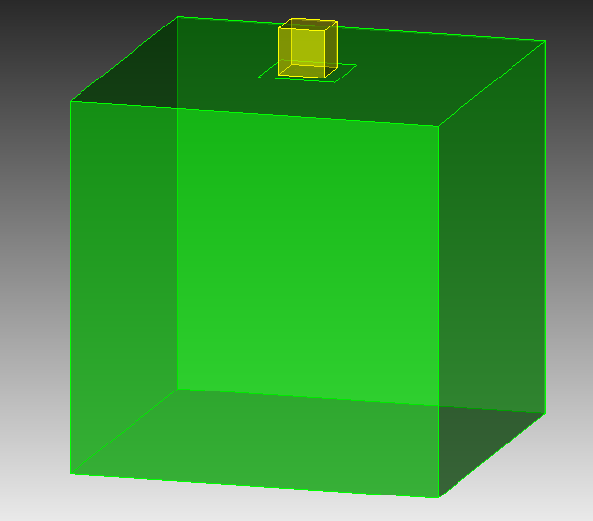

Figure 1 – Typical Input model in MASTODON

* The concrete and the soil blocks are assigned the following elastic properties.

|  |  |  |  |  |
| --- | --- | --- | --- | --- |
| **Material** | **E (psi)** | **µ** | **ρ (lb s2/in4)** | **ρ (pcf)** |
| Concrete | 4.00E+06 | 0.25 | 3.00E-04 | 200 |
| Soil | 1.39E+05 | 0.3 | 1.36E-03 | 90 |

where E = Young’s Modulus

µ = Poisson’s Ratio

ρ = Density

* Gravity is the only vertical force taken into consideration.
* Damping is ignored.
* A prescribed displacement in the form of a sinusoidal wave (shown in Figure-2) is applied to one of the sides of the concrete block in a direction parallel to the contact surface.
* The amplitude of the sinusoidal wave, the coefficient of friction between the contact surfaces and level of embedment are varied.
* The resulting normal and frictional force acting at the interface are obtained and compared with analytical results.
* Static analysis is conducted prior the dynamic analysis to stabilize the system under gravity loads.

Mesh block –

* The meshes are generated using Trelis Pro 16.5 and imported into MASTODON using **FileMesh** type specified within the **Mesh** block.
* Since the concrete is given a specified displacement, “Iteration” Patch_update_strategy ensures accurate contact detection.
* Default patch size of 40 is used. Patch size specifies the neighbourhood size of master nodes which are close to the slave node.

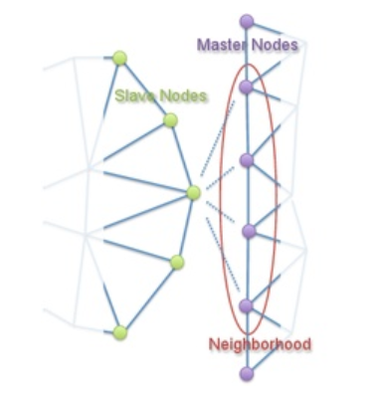

Variables block –

* The displacement variables are defined in the **Variables** block.
* The acceleration, velocity, stress, strain and various contact variables are defined in the **AuxVariables** block.

Kernels block –

* The dynamics of the block is modelled using **TensorMechanics** and **InertialForce** kernels.
* Gravitational force is applied using the **Gravity** block.
* The Auxiliary Kernel **PenetrationAux** is used for computing several geometry related quantities between the contacting bodies.
* Newmark’s average acceleration method (beta = 0.5, gamma = 0.25) is used.

Boundary Conditions block –

* All faces (apart from top surface) of soil block are fixed in all directions.
* Preset displacement (typical profile shown in Figure-2) is applied to one of the sides of the concrete block.

Figure-2 Input displacement Profile

Materials block –

* The**[ComputeIsotropicElasticityTensorBeam](https://mooseframework.inl.gov/mastodon/syntax/index.html)** block is used to create the elasticity tensor of the solid block and the elastic soil, using Young's Modulus and Poisson's ratio specified in the problem description.
* The stresses and strain are calculated using [**ComputeFiniteStrainElasticStress**](https://mooseframework.inl.gov/mastodon/syntax/index.html) and **[ComputeFiniteStrain](https://mooseframework.inl.gov/mastodon/syntax/index.html)**. The densities are assigned to the solid block and the soil using **[GenericConstantMaterial](https://mooseframework.inl.gov/mastodon/syntax/index.html)**.

Contact block –

* **Contact** Module in MOOSE provides a brief description of the parameters within the contact block.
* Currently, contact can be modelled as frictionless, glued and coulomb.
* The coulomb model is used for frictional contact. The standard coulomb friction model assumes that no relative motion occurs if frictional force is less than critical force.

τ = µ*N

where µ = coefficient of friction

N = Normal Force

* The master/slave concept is used where the slave nodes are restricted by the master nodes.
* The penalty formulation with a penalty factor = 1e4 is used. The factor penalizes the penetration of the master surface into the slave surface. Large penalty factor results in lesser penetration but has convergence issues whereas small penalty factor gives inaccurate answers.

Controls block –

* Static analysis is conducted by turning off the inertial terms for the first time-step. This stabilizes the system under the gravity loads.

**Simulations ran –**

|  |  |  |  |  |
| --- | --- | --- | --- | --- |
| Sr. No. | Embedment (%) | Amplitude (inches) | Coefficient of friction | Model |
| 1 | 0 | 0.03 | 0.1 | Coulomb |
| 2 | 0 | 0.03 | 0.4 | Coulomb |
| 3 | 0 | 1 | 0.1 | Coulomb |
| 4 | 0 | 1 | 0.4 | Coulomb |
| 5 | 0 | 1 | NA | Frictionless |
| 6 | 25 | 0.03 | 1 | Coulomb |
| 7 | 50 | 0.03 | 1 | Coulomb |

Table - 1

**Results for 0% embedment case–**

* Normal Force

Figure – 3 Normal force

* It is quite evident that the normal force all the cases of 0% embedment overlap each.
* Analytical Normal force = Density x gravity x Volume = 25.019 lbf
* Hence, the normal force obtained from MASTODON is accurate.
* Frictional force (or tangential force along x-direction)

Figure – 4 Frictional force

* Depending on the coefficient of friction (0.1 or 0.4), the maximum frictional force acting is 2.5 lbf or 10 lbf (obtained from MASTODON).
* Frictional force is 0 for frictionless model which is trivial.
* Analytical frictional force = coefficient of friction x Normal force = 2.5 or 10 lbf.
* Displacement vs frictional force

Figure – 5 Displacement vs Frictional force

**Erroneous Results for Concrete block embedded into the soil –**

The results obtained from MASTODON due dynamics of the concrete block have stability issues (Figure – 6).

Figure – 6 Original Output Acceleration

However, upon averaging the obtained results, the output acceleration and input acceleration (double differentiating the displacement input) seem to match closely (Figure – 7). This approach is inaccurate and physically incorrect (presented in version 2.0).

Figure – 7 Averaged Output Acceleration & Input Accleration

Figure – 8 Normal force along z

* The correct value for the normal force along z = - 25.013 lbf.
* Similar trend are observed with frictional force.
* The parameters computed using the **PenetrationAux** kernel produce erroneous results for simulations having embedment greater than 0 % (Figure – 8).
* This is due to the Penalty formulation used to enforce contact which penalizes the penetration of the concrete block into the soil (Figure – 9).
* Currently, the only other alternative is to use Kinematic formulation, but it suffers from convergence issues.

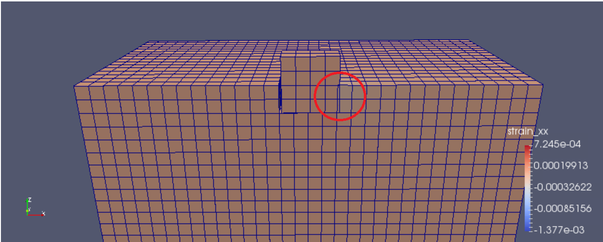

Figure – 9 Mid-section along XZ-plane exhibiting penetration

* The displacements are magnified by 100 in figure – 7.

**Erroneous Results for 0% embedment case with varying input displacement starting at t = 0 sec –**

Displacement plots –

* In modified 1-cos input, the displacement starts from t = 0.005 sec instead of t = 0 sec.

Acceleration plots –

**Erroneous Results for 0% embedment case with varying input displacement starting at t = 0.5 sec –**

**Results from MASTODON example – 6a**